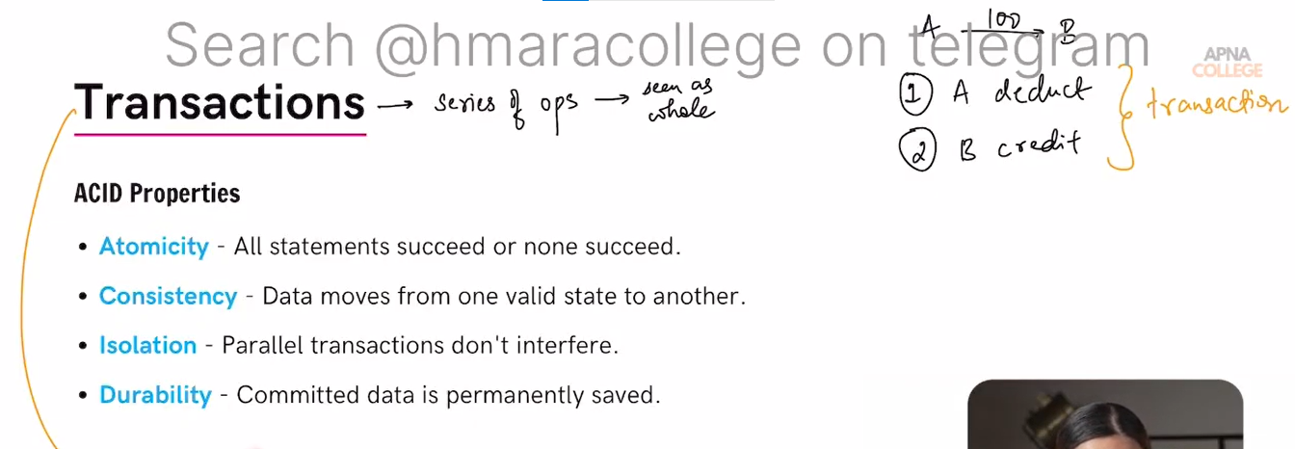
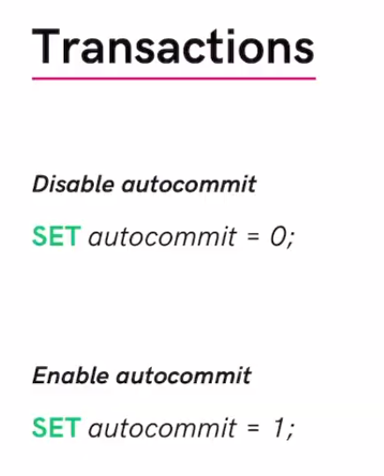
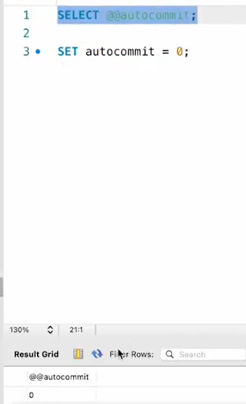
To Start the transaction we have to first make auto commit disable.Because for each query the transaction commit auto and we want commit series of operation commit simultaneously
SELECT @@autocommit;
SET autocommit = 0;

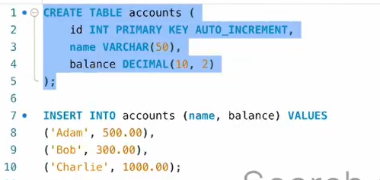
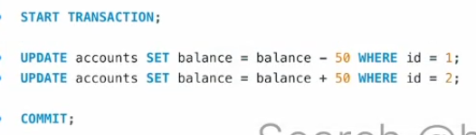
Adam salary deducted and bob salary credited and changes save in db permanently as commit statement run.
Rollback
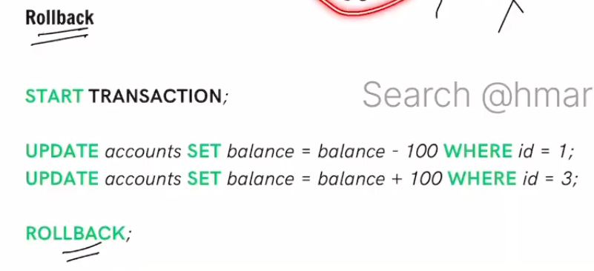
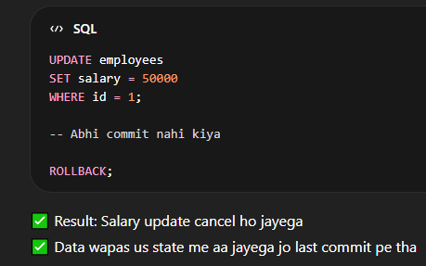
It undo the un-committed changes.
Means agr commit nhi hua h and rollback statement run krte hii it rollback to previous commit state.

Savepoint
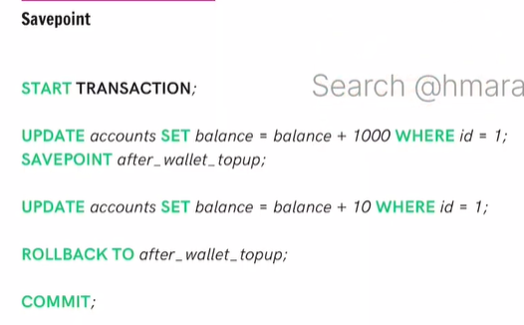
Suppose a paytm wallet
We add 1000, it adds to account of id=1 and give 10 cashback
But at cashback may encounter to some error so transaction will rollback to that savepoint.
Then paytm will initiate trans for cashback and compulsory trans committed.

